**Crib Sheet for Government HP Laptop**

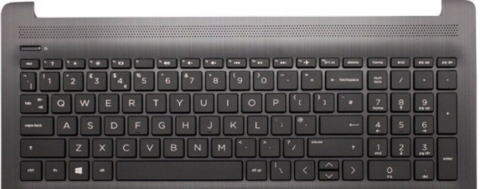**Switch On**

1. Plug device into mains if battery low (**battery** plug supplied). Input on left side of laptop.
2. 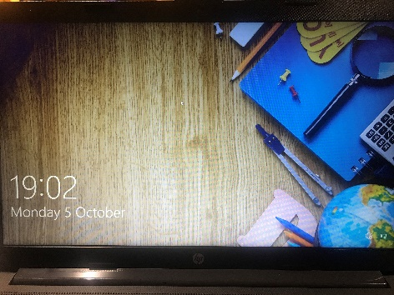Press **power button** on left hand side of the laptop above esc button.
3. Allow 10 seconds for laptop to boot up into **lock screen**.

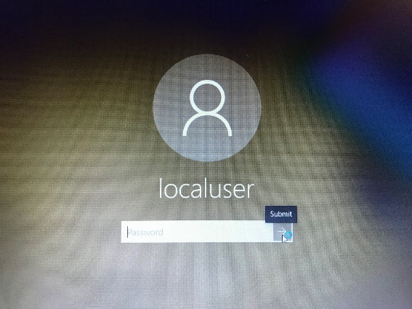

**Log In**

1. **Press enter** to view user access (login screen) – the correct user should be **localuser** and may pre-set. If showing correctly, no need to enter a password just press **enter** on keyboard or **submit arrow** on screen.

This will open up the desktop.

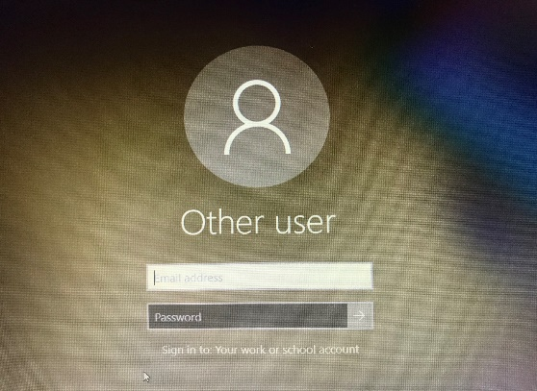

Troubleshoot: If your laptop shows .\localadmin or Other User type in **.\localuser** where it asks for your email address.

Press **enter** or **submit arrow** to open desktop, no password needed. User will now be set correctly as localuser for all future use.

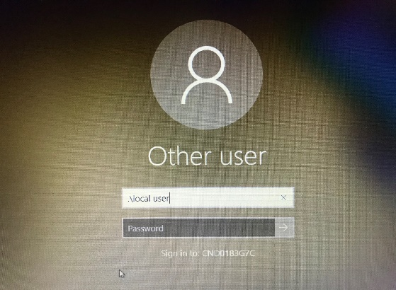Clarifying The Government set up these laptops in 2 ways

If username says local **user**

just press enter and it will take you to login

if username says local **admin**

type

.\localuser

Will ask for your email enter- then press enter to login.

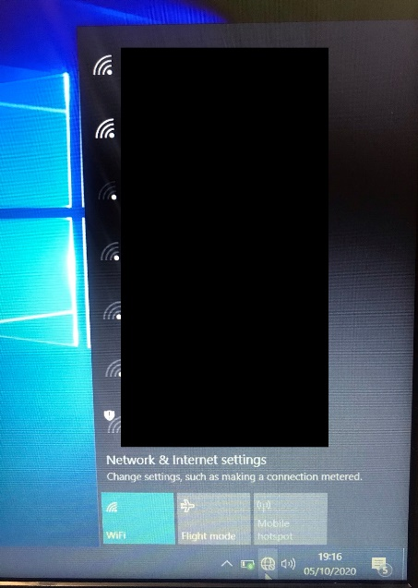

**Connect to Wi-Fi**

Your device needs access to a Wi-Fi network before you can use the internet.

1. Click the **Network icon** on the taskbar at the bottom right-hand corner. All available networks will appear.



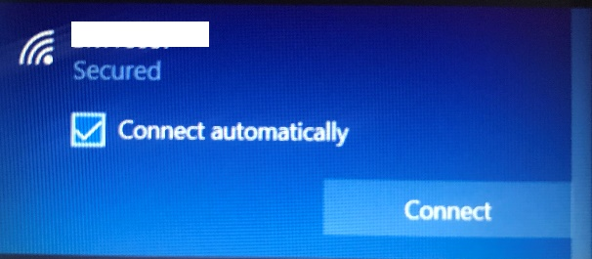

1. Select your Wi-Fi Network (will be on your router box under ‘wireless name’) and it will ask you to **Connect**.
2. 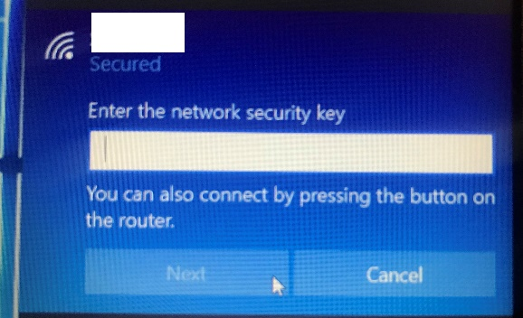Press Connect and you will be asked for your network **security key**. You will be able to find your security key on the **router box** under ‘security key’ or ‘password’.
3. **Type in** and select **Next**.

**Web Browser Options**

**Microsoft Edge** (Preferred Option)

The **fastest web browser** designed for Windows 10. Your laptop will have Microsoft Edge pre-installed.

Select **Start menu** and scroll to find (A-Z) or type it into the **search bar** on the laptop.

May also be saved on **desktop** under icon



**Chrome**

Chrome is another advanced web browser provided by google. Your laptop will have Chrome pre-installed.

Select **Start menu** and scroll to find (A-Z) or type it into the **search bar** on the laptop.

May also be saved on **desktop** under icon

**Safeguarding**

**Staying safe online** – This laptop is registered to the DfE so safeguarding settings are pre-applied. You will not be able to use this device to access any inappropriate content.

If you’re worried that your child is accessing harmful content on any device, you can receive support and advice online at [http://www.gov.uk/guidance/safeguarding-and-remote-eduction-during- coronavirus-covid-19](http://www.gov.uk/guidance/safeguarding-and-remote-eduction-during-%20coronavirus-covid-19)

**Essential Software**

All Government laptops have **Microsoft Intune** installed to prevent users from making changes, such as removing security settings and installing new software. This is to ensure safeguarding measures are in place.

All laptops will have certain apps and software pre-set such as **Wordpad** but if you need additional software we advise you use **online options** or **contact your school** for overwrites.

References:

**WordPad:**

Select **Start menu** and scroll to find (A-Z) or type it into the **search bar** on the laptop.

This free software is more advanced than Notepad however not as advanced as Microsoft Word. It can support pictures and text formatting.

**Google Docs**: <https://accounts.google.com/signup/v2/webcreateaccount?continue=https%3A%2F%2Fdocs.google.com%2F&flowName=GlifWebSignIn&flowEntry=SignUp>

**Microsoft Office online version**:

https://www.microsoft.com/en-gb/microsoft-365/free-office-online-for-the-web

**Further Guidance**

Common Questions: <https://sites.google.com/lgfl.net/national-grid-for-learning/dfelaptops>

Website: https://dfelaptops.lgfl.net

Support Line: 0203 8418882